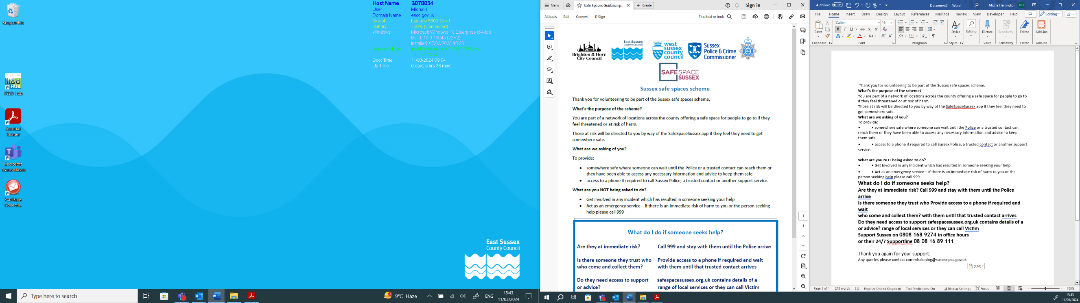

Safe Spaces Scheme Information and Criteria

This document sets out the criteria that is to be used to assess new applications to be part of the Safe Spaces Scheme. This applies to all new applications from the 1 April 2024.

“Safe Spaces” already part of the network prior to the 1 April 2024 will be contacted by a volunteer who will carry out a re-assessment (either in person or over the phone), or they will be asked to complete a self-assessment document to confirm they meet the criteria.

What’s the purpose of the scheme?

Safe Spaces Scheme was set up to form a network of locations across the county offering a safe space for people to go to if they feel threatened or at risk of harm.

You can find a Safe Space, and subsequent navigation to, on www.safespacesussex.org.uk

Criteria to become a Safe Space

Application

Sites are required to complete an application form and submit it to the Office of the Sussex Police and Crime Commissioner either by emailing safespacesussex@sussex-pcc.gov.uk or by writing to:

Sussex Police and Crime Commissioner
Sackville House
Brooks Close
Lewes
East Sussex
BN7 2FZ

As part of the application we will require the following information:
- Full address
- Named lead contact and position within the company/business
- Contact details of lead contact
- Days and times available as a Safe Space
- Accessibility to the space (e.g. does it have wheelchair access)
- Facilities available (toilet, drink water, private place to sit, access to a phone)
- Who would be present within the Safe Space (e.g. what staff, any volunteers, security)
- Is there CCTV in use at the space?
- If the venue is part of any other similar scheme? This won’t exclude them from the Safe Spaces Scheme, but will allow us to provide more details of the different Safe Spaces on the site.
- Any additional information that they feel would be useful for someone seeking a Safe Space to know (such as if a first aider is always on site, have staff received safeguarding training, are there security guards on site)
- Any risks they are aware of associated with the space being used as a Safe Space (for example, does any other organisations use the space at the same time it is being offered as a Safe Space)

The Site

To be accepted as part of the Safe Space Scheme, all of the below criteria needs to be met:

- Ability to provide a private, secluded area that is not accessible to the public. Additionally, one that staff members will NOT require to use whilst someone is using the Safe Space. Note - The user does not have to use this space, and may feel more comfortable in a public area
- Access to a phone, that can be used in the identified Safe Space in the building. Staff are not expected to offer the use of their personal phones. This is to allow a call to be made to Sussex police, a trusted contact or another support service.
- There is always more than one staff member on the premises during the times it is being offered as a Safe Space.
- To provide access to a toilet, drinking water and a place to sit down.

The criteria will be assessed by a site visit conducted by either a member of staff from the Office of the Sussex Police and Crime Commissioner or by a volunteer acting on our behalf.

Complaints

If you have any questions or concerns around the Scheme, a venue you may have accessed as a Safe Space, or a Safe Spaces Scheme volunteer, please contact SafeSpaceSussex@sussex-pcc.gov.uk where it will be reviewed by the Head of Commissioning and Victim Services.

Removal of a Safe Space

If any concerns have been raised about a venue listed as a Safe Space and it has been assessed as not suitable, then it will be removed as a listing and the decision will be communicated through to the member.

If the member believes that they shouldn’t have been removed, contact should be made to safespacesussex@sussex-pcc.gov.uk and the decision will be reviewed by the Head of Commissioning and Victim Services within 30 days.

