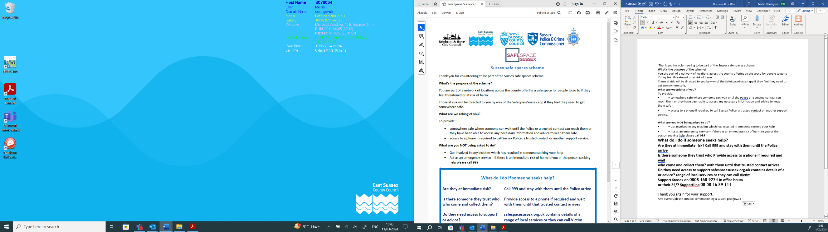

Safe Spaces Scheme- New Member Application Form

Venue name
Address
Postcode
Name of lead contact (including job title)
Contact details of lead contact
Days and times available as a Safe Space
Is there always more than one member of staff on the premises? Please provide any details of who this may include.
What facilities are available? | Private secluded area for use  Toilet  Water  Access to phone
Is the venue and the facilities wheelchair accessible?
Is there any other information you think would be helpful to provide? (e.g. does anyone else use the location)
Is there CCTV in use at the space? If yes, please provide details of where it is located and what areas it covers?
Are you part of any other similar scheme?
I understand that these details will be shared with those who assess the applications for suitability of inclusion on the scheme. Contact will be made to arrange a site visit.
I understand that following assessment, if the venue is approved as a Safe Space, the responsibility to keep the Scheme updated with any changes to the information provided above (or provided during the site visit) lies with the lead contact stated on this form. Any updates should be made by emailing SafeSpaceSussex@sussex-pcc.gov.uk or by using the Self Serve Login on www.safespacesussex.org.uk
I agree to make the Scheme aware (through the contact email above), if we receive any concerns or complaints that may mean we are no longer suitable as a Safe Space.
I agree that the Member Information and Training Document will be provided to all staff for awareness.
I agree to put the materials shared by the Scheme as required (window sticker, posters, leaflets).
Signed:

Name:

On behalf of:

Date:

Please send the completed form to safespacesussex@sussex-pcc.gov.uk

