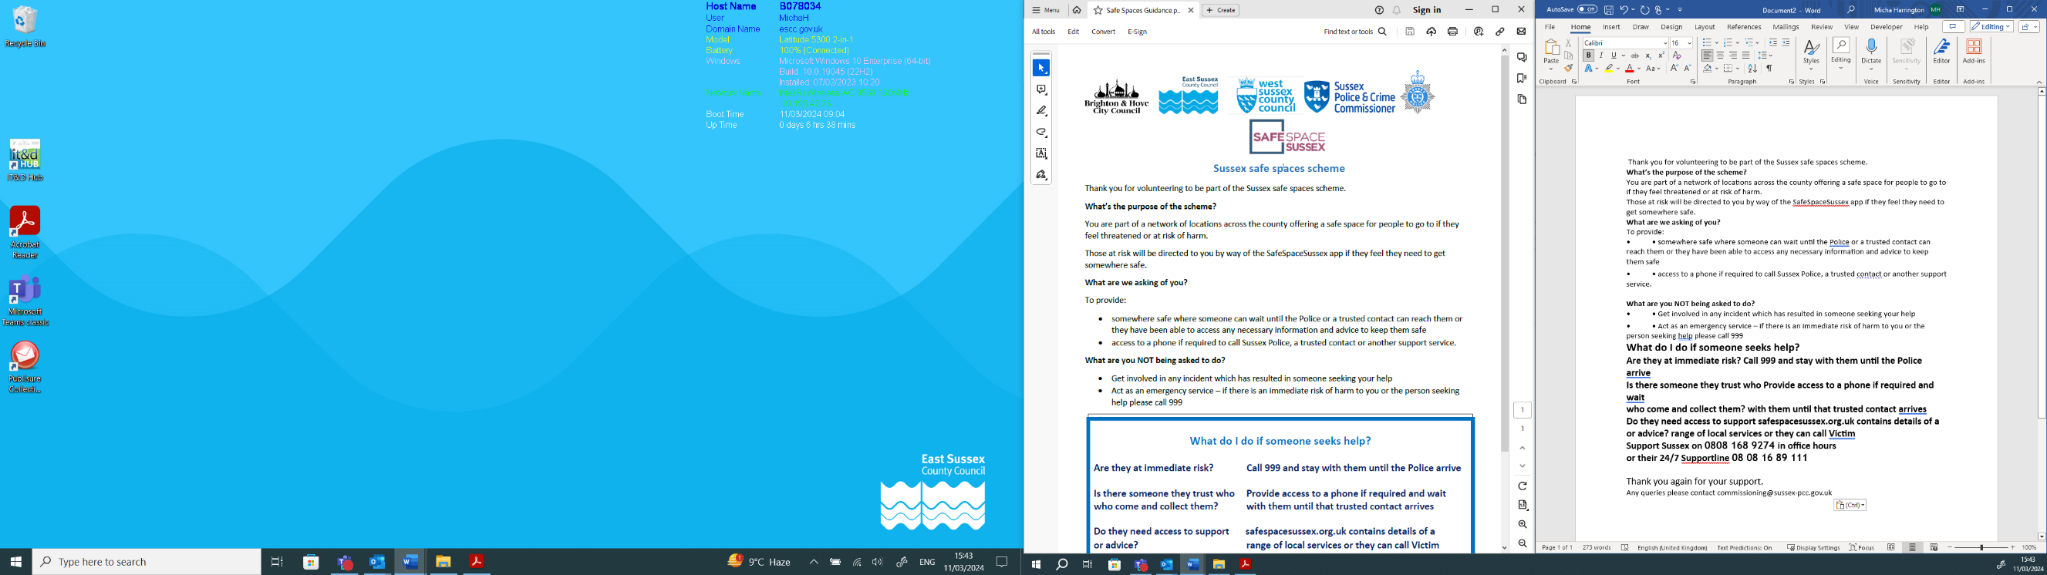

Safe Spaces Scheme
Member Training Document

What is the Safe Spaces Scheme?
The Safe Spaces Scheme was developed in 2021 to help those who may find themselves feeling unsafe in Sussex. Venues sign up to become designated ‘safe spaces’, providing a place for people to go, feel safe and call for help.
Your organisation has signed up to the scheme and has therefore agreed to:

- To provide a safe place where someone can wait until the Police or a trusted contact can reach them or they have been able to access any necessary information and advice to keep them safe

- Offer a private, secluded area that is not accessible to the public should they wish to use
- To provide access to a phone to call Sussex Police or a trusted contact, if needed
- To provide access to a toilet and drinking water whilst they are accessing the Safe Space

Who should read this document?
Anyone who is front facing and may be approached by a member of the public.

Why might someone need/want to access a Safe Space?
There are various reasons why someone might feel unsafe or vulnerable and want or need a Safe Space. This could be:
- Being harassed- Another person is verbally abusing them, following them, shouting or making noises to bother them
- Feeling unsafe in that area- The area is new to them, not well lit or there are other environmental factors that mean they don’t feel safe walking or navigating to where they need to go
- Personal condition- Due to levels of alcohol or other reasons, they don’t feel in a position to protect themselves or get themselves to their destination safely
- There are many reasons why someone can feel or become vulnerable. It is important to be open, understanding and non-judgmental

What you should and shouldn’t do if someone asks for a Safe Space
If someone comes into your premises and asks for a Safe Space, you should:
- If there is an immediate risk of danger or the person needs immediate critical medical attention call 999.
- Offer them the private area that has been designated as a Safe Space
- Offer them the use of the telephone
- Offer them a drink of water
- Make the person feel welcome

What are you not being asked to do?
- Act as an emergency service – if there is an immediate risk of harm to you or the person seeking help, call 999
- Get involved in any incident which has resulted in someone seeking your help
- Provide a support service or provide counselling
- Provide medical support (unless you are qualified to do so)
- Offer the use of your personal phone

How to talk to someone who wants to access the Safe Space
When approached by someone in distress, or who seems vulnerable, remember the following steps:
- Give the speaker your attention and acknowledge them
- Don’t interrupt them
- Respond calmly and discreetly
- Try and show open and inviting body language- arms not crossed, smiling, standing up, nodding
- Confirm that you are a Safe Space venue and ask if they need a private space to sit, any facilities or a phone to use to call a contact
- Offer to wait with them until a trusted contact arrives
- When they are ready to leave, or a contact has come to pick them up, show them out safely

If the person is in extreme distress following becoming a victim of crime, signpost them to the Victim Support Helpline on 0808 168 9274 in office hours, or their 24/7 Supportline on 08 08 16 89 111.

You can also signpost them to www.safespacesussex.org.uk where they can find a support service. Leaflets can also be provided which can be left in the Safe Space.

Risk assessment:
As part of the Safe Spaces Scheme criteria, we ask that there is always more than one member of staff on site at any time. This is to help keep the member of public safe as well as any staff member of the venue.
Staff members should be aware of their internal safety and safeguarding processes and policies.
Although the ask of any Safe Space is to only offer a place to sit and a phone, members should be aware that at any time a member of the public may approach them due to an emergency and that in these circumstances 999 should be called and the appropriate emergency service asked for.
Staff should follow any internal policies on how to safeguard themselves and anyone else as appropriate.
Manager Checklist:
Following your venue/business signing up as a Safe Space location, you will have had a visit from a member of staff/volunteer on behalf of the Sussex PCC office to assess the suitability of the place being offered.
Following approval onto the scheme, your location will be loaded up onto the system to show as a Safe Space venue.
It is the responsibility of the business and or appropriate key contact to ensure the following steps are then taken:
Item | Completed? | Comments:
All staff are aware that the venue is now a Safe Space
All staff have been provided with this training document and the member information document
All staff are aware of which private space can be used as a Safe Space and the facilities to be offered
If not already part of staff training, consider implementing a vulnerable persons and safeguarding policy. If one is not in place, ensure staff are aware of how they should safeguard themselves
The Safe Spaces Scheme Member window sticker and any posters are displayed
The internal guidance for staff is displayed in an appropriate, easy to access place
Safe Space Sussex leaflets are provided within the private space. (If you need more, please let us know and we will send some out)

Further training and schemes:
To help support you and any staff as a Safe Space, you may find the following of interest to look into and provide for your employees:
- Ask for Angela Scheme and attached training
- Bystander intervention training
- Mental health first aid training
- First aid training

